* **Multiagent environments**
  + Consider them in aggregate as an economy (appropriate for large number of agents)
    - Allows predictions like ‘increasing demand will cause prices to rise’ without having to predict action of any individual agent
  + Consider adversarial agents as part of the environment that makes it nondeterministic
    - But if we model adversaries nondeterministically(e.g.rain may fall, may not), we miss the idea that our adversaries are actively trying to defeat us
  + Explicitly model adversarial agent with techniques of **adversarial game-tree search**
* **2-player zero-sum games**
  + 2 player, turn-taking, perfect information, zero-sum games
    - Zero-sum: what’s good for one player is bad for the other
    - Perfect information: fully observable
  + Formal model
    - *S0:* Initial state
    - TO-MOVE(*s*): player whose turn it is to move
    - ACTIONS(*s*); set of legal moves in state *s*
    - RESULT(*s*, *a*): transition model
    - IS-TERMINAL(*s*): terminal test, true if the game is over or false otherwise
    - UTILITY(*s, p*): utility function that defines final numeric value to player *p* when game ends in terminal state *s*
  + ACTIONS and RESULT define state space graph
    - Can superimpose search tree over the graph
    - **Game tree**: search tree that follows every sequence of moves until terminal state
      * Might be infinite if state space is unbounded or rules allow infinite repeating positions
* **Optimal Decision Making -** strategy must be conditional and have contingencies specifying response to adversary’s moves
  + Can use AND-OR search for games with binary (win/lose) outcome for plan
    - Definition of winning strategy for game is identical to definition of solution for nondeterministic planning problem
  + **Minimax search:** For games with multiple outcome scores, need a more general algorithm
    - **Ply**: one move by one player
    - **Minimax value** (MINIMAX(*s*))**:** Utility for player being in that state assuming both players play optimally from there to the end of the game
      * Minimax value of terminal state is just its utility
      * Assumes both agents only play optimally

**Minimax Value Example** Max, Min. Max wants higher number Min wants lower number

* MINIMAX(B) = 3 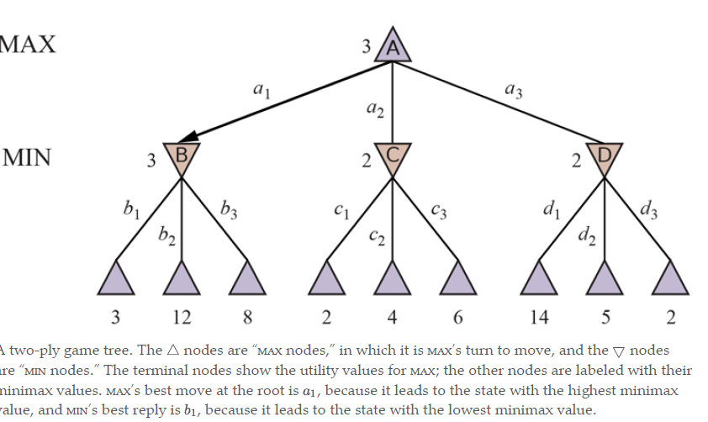
  + B is Min’s move, Min wants lowest number, so it would select 3
* MINIMAX(C) = 2
  + C is Min’s move, lower number
* MINIMAX(D) = 2
  + C is Min’s move
* MINIMAX(A) = 3
  + A is Max’s move, wants highest number
  + **Minimax decision:** a1 is the best move because it leads to the state with highest minimax value

**Doesn’t always mean it’s best to play minimax optimal move when facing suboptimal opponent**

* **Minimax search algorithm** - finds best move by trying all actions and choosing the one whose resulting state has the highest MINIMAX value
  + Recursive that proceeds all the way down to leaves of tree and backs up minimax values through tree as recursion unwinds
  + Complete depth-first exploration
  + Space time complexity
    - *m*: maximum depth of tree
    - *b*: legal moves at each point
    - Time: O(*bm*)
    - Space: O(*bm*) if algorithm generates actions all at once
      * O(*m*) if generates actions one at a time
  + Impractical for complex games
* **Minimax for Multiplayer games**
  + Utility vector (v1, v2, v3,...vn)
    - In two player zero sum games two element vector can be a single value because values are always opposite
  + For terminal states, vector is utility of the state from each player’s viewpoint
  + For leaves, it’s the **backed up value**
    - Backed value of a node *n* is the utility vector of the successor state with the highest value of the player choosing *n*
  + **Alliances can be a natural consequence of optimal strategies for each player in multiplayer game**
    - Collaboration can emerge from purely selfish behavior
    - Players must balance immediate advantage of breaking an alliance against long term disadvantage of being perceived as untrustworthy
    - If game isn’t zero-sum collaboration can occur with just 2 players
* **Alpha-beta pruning** - pruning large parts of the game tree that make no difference to the outcome
  + Value of the root and minimax decision are independent of the values of the leaves, so some leaves can be pruned
  + Possible to prune entire subtrees rather than just leaves
  + General principle
    - Consider node *n* such that player has a choice of moving to *n*
    - If player has better choice either at the same level or at any point higher up in the tree, player will never move to *n*
    - Once we’ve found enough about *n* by examining its descendants to reach this conclusion, we can prune *n*
  + Gets name from two parameters that describe bounds on backed-up values that appear anywhere on the path
    - $α$- value of the best (highest) choice we have found so far at any choice point along the path (at least)
    - $β$- value of the best choice (lowest) choice we’ve found so far at any choice point along the path (at most)
  + Alpha-beta search updates values of $α$ and $β$ as it goes along and prunes remaining branches as soon as the value of the current node is known to be worse than current $α$ or $β$ for the respective player
* **Effectiveness of alpha-beta pruning is dependent on the order in which states are examined**
  + Might be worthwhile to try and examine the successors that are likely to be best
    - If done perfectly alpha-beta would only need to examine O(*bm/2*) nodes instead of O(*bm*)
    - Effective branching factor becomes $\sqrt{b}$ instead of *b*
    - Alpha-beta with perfect move ordering can solve a tree roughly twice as deep as minimax in the same amount of time
  + With random move ordering total number of nodes examined is O(*b3m/4*)
  + Perfect move ordering is impossible, but simple ordering functions help too
  + Dynamic-move ordering schemes (trying first moves that were found to be best in past) helps a lot
    - Could come from previous exploration of current move through a process of iterative deepening
      * Search one ply deep, record ranking of moves based on evaluations
      * Then one ply deeper, using previous ranking to inform move ordering
    - Increased time from iterative deepening can be made up from better move ordering
  + **Killer move heuristic:** finding the best move first
* **Transpositions** - different permutations of the move sequence that end up in the same position (repeated states)
  + **Transposition table**: Caches heuristic value of states
  + After exploring subtree below some state, can find its backed-up minimax value, which is stored in transposition table
    - Later when we end up in same state from a different set of moves, we can look up the value instead of repeating search
* **Even with alpha-beta pruning and move ordering, minimax often doesn’t work because there are too many states to explore in the time available**
  + **Type A strategy**: Explore a wide but shallow portion of the tree
    - Consider all possible moves to a certain depth in search tree and uses heuristic evaluation to estimate utility of states at that depth
    - Most chess programs have been Type A
  + **Type B strategy:** Explore a deep but narrow portion of tree
    - Ignores moves that look bad and follow promising lines as far as possible
    - Most Go programs are Type B
    - Type B programs show higher level of play

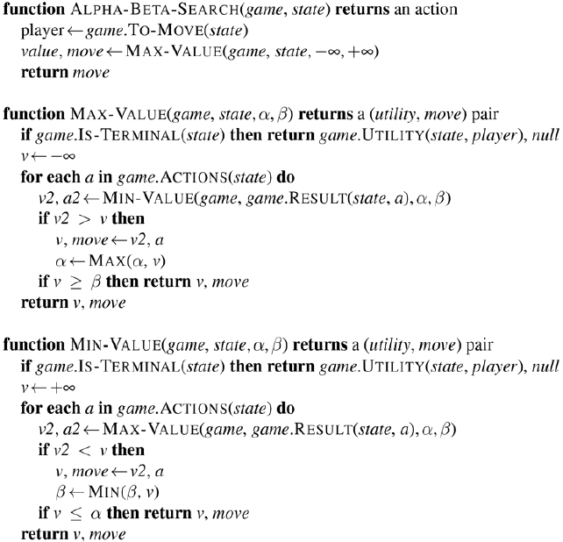



* **Heuristic Alpha-Beta Tree Search**
  + Can cut off search early and apply heuristic evaluation function to states
    - Treat nonterminal nodes as if they were terminal
  + Replace utility function with **evaluation functions**
    - Estimates a state’s utility
  + Replace terminal test with **cutoff test**
    - Decides when to cut off the search based on search dept and any property of the state that it chooses to consider
      * Must return true for terminal states

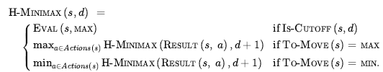

* **Heuristic evaluation function** EVAL(s, p) **returns an estimate of the expected utility of the state *s* to player *p***
  + For terminal states
    - EVAL(*s, p*) = UTILITY(*s, p*)
  + For nonterminal states
    - UTILITY(*loss*, *p*) $≤$ EVAL(*s, p*) $≤$ UTILITY(*win*, *p*)
  + What makes for a good evaluation function?
    - Can’t take too long
    - **Should strongly correlate with actual chances of winning**
      * If the search must be cut off at nonterminal states, algorithm will necessarily be uncertain about final outcomes of those states
      * Doesn’t need to be a linear correlation
      * **If state *s* is twice as likely to win as *s’* it’s not required that EVAL(*s*) is twice of EVAL(*s’*). Only EVAL(*s*) > EVAL(*s*’)**
  + Most eval functions work by calculating various features of the state
    - Features taken together define various equivalence classes of the state
      * States in each category have the same values for all features
  + Does not know which states are watch but returns a single value that estimates the proportion of states with each outcome.
    - **Expected value**: determined for each category of states resulting in eval function that works for any state
  + **Most eval functions compute separate numerical contributions from each feature and then combine them to find the total value**
    - E.g. material value in chess (pawn = 1, knight = 3, etc.)
  + **Weighted linear function**
    - fi = feature of the position
    - wi = weight of the position
    - Weights should be normalized so that sum is within range of zero (loss) to +1 (win)
  + Adding up values of features assumes **that the contribution of each feature is independent of the values of the other features**
    - Other games use nonlinear combinations of feature
      * E.g. a bishop in chess is worth more in the endgame
* **Cutting off search**
  + Call heuristic EVAL when it’s time to cut off the search
    - IS-TERMINAL -> IS-CUTOFF
    - UTILITY -> EVAL
  + Most straightforward approach to controlling amount of search is setting fixed depth *d*
    - Need current depth incremented on each recursive call
    - IS-CUTOFF =true for all depth greater than *d* (as well as for all terminal states)
    - *d* is chosen so that move is selected within allocated time
    - Iterative deepening would be more robust
      * When time runs out program returns move selected by deepest completed search
      * Can cache entries in transposition table
      * Can use evaluations to improve ordering
  + **Evaluation function should only be applied to quiescent positions**
    - Quiescent position = positions where there are no pending moves that would wildly swing the evaluation
    - **Quiescent search**
      * For nonquiescent positions IS-CUTOFF = false and search continues until quiescent position is reached
      * Sometimes restricted to consider only certain types of moves that quickly resolve uncertainties in the position
  + **Horizon effect** arises when program is facing opponent’s unavoidable move that causes serious damage but can be temporarily avoided using delaying tactics
    - While tactics seem like good moves right now, they just delay the inevitable
    - How can we mitigate horizon effect?
      * Allow **singular extensions**: moves that are clearly better than all other moves, even when search would normally be cut off by that point
* **Forward pruning** - pruning moves that appear to be bad but might be good
  + Strategy saves time at the risk of an error (Type B strategy)
  + Forward pruning with **beam search**
    - Consider only a beam of best *n* moves rather than all possible moves
      * Best move could be pruned away
  + **Probabilistic cut**: forward pruning alpha beta search that uses statistics gained from prior experience to lessen the chance that best move will be pruned
    - Prunes nodes that are *probably* outside current alpha beta window
    - Computes probability by
      * shallow search to compute the backed up value *v*
      * Use past experience to estimate how likely that a score of *v* at depth *d* in the tree would be outside alpha beta window.
  + **Late move reduction**: assumes move ordering has been done well so moves that appear later in the list of moves are less likely to be good moves
    - Reduce the depth to which later moves are searched
    - If reduced search comes back with a value above current alpha, can rerun search with full depth
* **Search vs. lookup -** Use table lookup rather than search for opening and ending of games
  + For openings computer usually relies on human expertise
  + Computers can gather statistics from database of played games to see which opening sequences most often lead to win
  + At the start or end of the game there are fewer possible positions, so lookup is easier
  + Endgames can be tricky
    - Computers can produce a **policy** to solve the end game
      * Policy: mapping ever possible state to the best move in that state
      * Then computer plays perfectly using lookup
    - Table is constructed by retrograde minimax search
* **Monte Carlo Tree Search (MCTS)** - instead of heuristic eval function, value of a state is estimated as average utility over a number of simulations of complete games starting from the state
  + Simulation (aka playout, rollout) chooses moves for each player until terminal position is reached
  + Rules of the game determine who won and by what score
    - For games with binary outcome average utility = win percentage
  + How to choose what moves get made during simulation?
    - Need a **playout policy** that biases moves toward good ones
  + From what positions do we start playouts? How many playouts do we allocate each position?
    - **Pure Monte Carlo search**: do *N* simulations from currente state and track which possible moves from current position has highest win %
    - Need a **selection policy** that selectively focuses computational resources on important parts of game tree. Needs to balance
      * **exploration** of states that had few playouts
      * **exploitation** of states that have done well in past playouts
  + Four steps of maintaining a search tree and growing it each iteration
    - **Selection**: starting at root of tree, choose a move guided by selection policy leading to a successor node. Repeat process moving down the tree to a leaf
    - **Expansion**: grow search tree by generating new child of selected node
    - **Simulation**: perform playout from newly generated child node, choosing moves for both players according to playout policy
      * Moves aren’t recorded in search tree
    - **Back-Propagation**: Now use result of simulation to update all search tree nodes going up to root
  + Repeat steps for set number of iterations or until allotted time expired, then return move with highest number of playouts

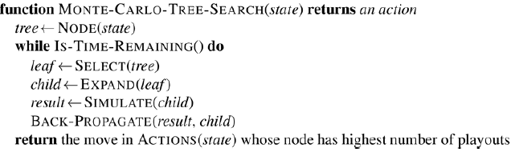

* + **Upper confidence bounds applied to trees (UCT)** - effective selection policy
    - Ranks each possible move based on upper confidence bound formula **UCB1**
      * **U(*n*)** - total utility of all playouts through node *n*
      * **N(*n*)** - number of playouts through *n*
      * **PARENT(*n*) -** parent node of *n* in tree
      * U(*n*) / N(*n*) is exploitation term
        + average utility of *n*
      * Term under square root is exploration term
        + *N(n)* is denominator which means term will be high for nodes that have only been explored a few times
        + Numerator has the log of number of times we’ve explored the parent of *n*
        + **If we are selecting *n* some non-zero percentage of time, exploration term goes to zero as the counts increase and eventually playouts are given to node with highest average utility**
      * *C* - constant that balances exploitation and exploration
        + Theoretically should be sqrt(2)
        + Usually multiple values are tried, and best one is chosen
    - Formula ensures that node with most playouts is almost always the node with highest win % because selection process favors win % more as number of playouts increase
  + **Time to compute a playout is linear not exponential**
    - Only one move is taken at each choice point
  + MCTS has advantage over alpha beta (AB) games where branching factor is very high or when it’s difficult to define good eval function
    - AB chooses path to a node that has highest achievable eval func score given that opponent trying to minimize score
    - If eval function is inaccurate, AB is inaccurate
    - Miscalculation can lead AB to choose/avoid a path to the best node
  + MCTS relies on aggregate of many playouts, not vulnerable to a single error like alpha beta search.
  + Can combine MCTS and eval functions
    - Do a playout for certain # of moves then truncate playout and apply eval function
  + Can Combine AB and MCts
    - Can use early playout termination
      * Stop a playout that’s taking too many moves
      * Evaluate it with heuristic function or just declare draw
  + MCTS can be applied to games where there is no experience to draw on eval function
    - All we need is rules of game
    - Selection and playout policies can be helped by expert knowledge but good policies can be learned using neural networks trained by self play
  + **MCTS has disadvantage when it’s likely that single move can change course of the game**
    - Type B pruning in MCTS means vital line of play may not be explored
  + **MCTS has disadvantage when some states are obvious wins for a side but where it’ll take many moves in playout to verify winner**
* **Stochastic games** - games that include a random element, combining luck and skill
  + Game tree in stochastic games need **chance nodes** in addition to max min nodes
    - E.g. Dice roll events
  + How can we pick the move that leads to the best position?
    - Positions don’t have definite minimax values
    - Calculate **expected value:** sum of the value over all outcomes weighted by probability of each chance action
  + **Expectiminimax** **value**: generalization of minimax (from deterministic games) for games with chance nodes

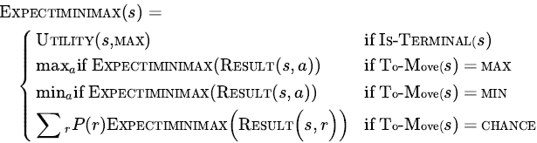

* **Evaluation functions for stochastic games must return values that are a positive linear transformation of the probability of winning**
  + Think of a game where a throw of dice precedes each move
    - There are no likely sequences of moves
    - Even the most likely move occurs only ½ of the time because for the move to take place the dice would first have to come out the right way to make it legal
  + Alpha-beta (AB) pruning can be applied to game trees with chance nodes
    - Can prune minimax and chance nodes
    - Put bounds on possible values of the utility function
      * Can arrive at bounds for the average without looking at every child of chance node
    - For games with high branching factor for chance nodes
      * Consider forward pruning that samples smaller number of possible chance branches
      * May want to opt for MCTS instead where playout includes random rolls
* **Partially observable games** are games with ‘fog of war’ e.g. don’t know where enemy is until revealed by contact
  + In deterministic partially observable games, uncertainty about state of the board arises entirely from lack of access to the choices made by opponent
    - E.g. battleship
    - E.g. Kriegspiel (partially observable variant of chess where pieces are invisible to opponent)
  + **Belief state** - set of all logically possible board states given the complete history of percepts to date
  + Keeping track of belief state as game progresses is the problem of state estimation in partially observable games
  + Instead of specifying a move to make for each possible move the opponent might make need a move for every possible percept sequence that might be received
  + **Guaranteed checkmate**: for each possible percept sequence leads to an actual checkmate for every possible board state in the current belief state regardless of how opponent moves
    - Opponent’s belief state is irrelevant, strategy has to work even if opponent can see all the pieces
  + AND-OR algorithm can be applied to belief state space to find guaranteed checkmates
  + **Probabilistic checkmate**: required to work in every board state in the belief state
    - Probabilistic with respect to randomization of the winning player’s moves
  + **Accidental checkmate**: strategy works for some of the board states in current belief state but not others
    - Can’t know it would be checkmate
    - How likely is a given strategy to win?
      * How likely is that each board state in the current belief state is the true board state?
    - Each player’s goal isn’t to just to move correctly, but also to minimize info that the opponent has about their location
  + **Optimal play in partially observable games requires a willingness to play somewhat randomly**
    - Playing predictable optimal strategy provides opponent with information
    - Occasionally selecting moves that may seem weak but gain strength from their very unpredictability because opponent is likely unprepared for it
    - Probabilities associated with board states in the current belief state can only be calculated given an optimal randomized strategy
      * Computing a strategy seems to require knowing probabilities of various states the board might be in
      * **Equilibrium** specifies optimal randomized strategy for each player
        + Can be really expensive
    - Most systems use bounded-depth look-ahead in their own belief state space ignoring opponent’s belief state
  + Card games feature **stochastic partial observability** - missing info is generated by random dealing of cards
    - Assumption: treat the start of the game as chance node with every possible deal as an outcome and then use EXPECTIMINIMAX to pick best move
      * Only root node is chance node, then game is fully observable to both players
      * “Averaging over clairvoyance”
      * Fails because it doesn't consider the belief state that the agent will be in after acting
        + Assumes every future state will automatically be one of perfect knowledge
        + Clairvoyant approach never selects actions that gather info
        + Won’t choose actions that hide info from the opponent

Because it assumes they know already

* + - Number of possible hands that can be dealt is too huge, use **abstraction** to treat similar hands as identical
    - Forward pruning: consider only a small random sample of *N* deals and calculate EXPECTIMINIMAX score
      * Can also do heuristic search with depth cutoff rather than search entire game tree
    - Consider: Is each deal equally likely for all card games?
* **Limitations of Game Search Algorithms**
  + Calculating optimal decisions in complex games is intractable. All algorithms must make some assumptions and approximations
    - AB search uses heuristic eval function to approximate
    - MCTS computes average over a random selection of playouts
      * When branching factor is high or it’s difficult to define evaluation function MCTS is preferred
  + Limitations of AB Search
    - Vulnerability to errors in heuristic function
  + Limitation of AB and MCTS
    - Designed to calculate bounds on the values of legal moves
      * Sometimes there’s one move that is obviously best (e.g. there’s only one legal move)
      * There’s no point wasting computation time to figure out value of move
      * Better implementation would use idea of **Utility of a node expansion** - selecting node expansions of high utility
        + Ones that are likely to lead to the discovery of significantly better move
        + If there are no expansions whose utility is higher than their cost the algorithm should stop searching and make a move
        + **Metareasoning** - reasoning about reasoning
  + Limitation of AB and MCTS
    - Do all their reasoning at the level of individual moves
      * Humans can reason at a higher-level goal (e.g. trap opponent’s queen in chess)
      * Use the higher level goal to selectively generate plausible plans
  + Good strategies should incorporate machine learning into the game search process